# Assignment No: 12 (c)

**PROBLEM STATEMENT:**

Write C++ program to to draw man walking in the rain with an umbrella. Apply the concept of polymorphism.

# PREREQUISITES:

Basic knowledge of graphics primitives.

# COURSE OBJECTIVE:

1. To implement the features of graphics.
2. To interface the applications of graphics to the real world.
3. To give some benefits to the disability.
4. To make the life easier.
5. To become familiarization with Graphics and its logical coding.

# COURSE OUTCOME:

To understand the concepts related to polymorphism and graphics primitives.

# THEORY:

Computer Graphics has revolutionized almost every computer-based application in science and technology. Information technology is a trend today.The importance of computer graphics lies in its applications. In engineering applications (e.g. automotive and aerospace) the ability to quickly visualize newly designed shapes is indispensible. Computer graphics has also expanded the boundaries of art and entertainment. Movies such as *“JURASSIC PARK”* make extensive use of computer graphics to create images that test the bounds of imagination. The development of computer graphics has made possible virtual reality, a synthetic reality that exists only inside a computer. Virtual reality is fast becoming an indispensable tool in education. Flight simulators are used to train pilot for extreme conditions. Surgical simulators are used to train novice surgeons without endangering patients.

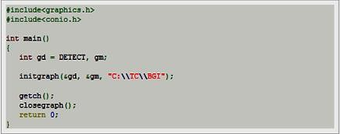

**Figure: Sample graphics program**

This program initializes graphics mode and then closes it after a key is pressed. To begin with we have declared two variables of int type gd and gm for graphics driver and

graphics mode respectively, you can choose any other variable name as you wish. DETECT is a macro defined in "graphics.h" header file, then we have passed three arguments to initgraph function first is the address of gd, second is the address of gm and third is the path where your BGI files are present (we have adjusted this accordingly where our turbo compiler is installed). Initgraph function automatically decides an appropriate graphics driver and mode such that maximum screen resolution is set, getch () helps us to wait until a key is pressed, closegraph () function closes the graphics mode and finally return statement returns a value 0 to main indicating successful execution of your program.

# Some of the function included in<graphics.h> used in our program:

**Line function:**line function is used to draw a line from a point(x1,y1) to point(x2,y2) i.e.(x1,y1) and(x2,y2) are end points of the line. The code given below draws a line.

**Declaration: -** void line (int x1, int y1, int x2, int y2);

**Circle function:** Circle function is used to draw a circle with center (x, y) and third parameter specifies the radius of the circle. The code given below draws a circle.

**Declaration: -** void circle (int x, int y, int radius);

**Setcolor function:** In Turbo Graphics each color is assigned a number. Total 16 colors are available. Strictly speaking number of available colors depends on current graphics mode and driver. For Example :- BLACK is assigned 0, RED is assigned 4 etc. setcolor function is used to change the current drawing color.e.g. Setcolor (RED) or setcolor(4) changes the current drawing color to RED. Remember that default drawing color is WHITE.

**Declaration: -** void setcolor (int color);

**Outtextxy function:**Outtextxy function display text or string at a specified point(x, y) on the screen.

**Declaration: -** void Outtextxy (int x, int y, char *string);

x, y are coordinates of the point and third argument contains the address of string to be displayed.

**Getmaxx function:** getmaxx function returns the maximum X coordinate for current graphics mode and driver.

**Declaration:-**int getmaxx ();

**Getmaxy function:** getmaxy function returns the maximum Y coordinate for current graphics mode and driver.

# Declaration:- intgetmaxy();

**Setlinestyle function:** Setlinestyle function sets line style, thickness, unsigned upattern etc.

**Declaration: -** void setlinestyle (intlinestyle, unsigned upattern, int thickness);

**Putpixel function:** putpixel function plots a pixel at location (x, y) of specified color.

**Declaration: -** void putpixel (int x, int y, int color);

For example if we want to draw a GREEN color pixel at (35, 45) then we will write putpixel (35, 35, GREEN); in our c program, putpixel function can be used to draw circles, lines and ellipses using various algorithms.

**Setfillstyle function:** setfillstyle function sets the current fill pattern and fill color.

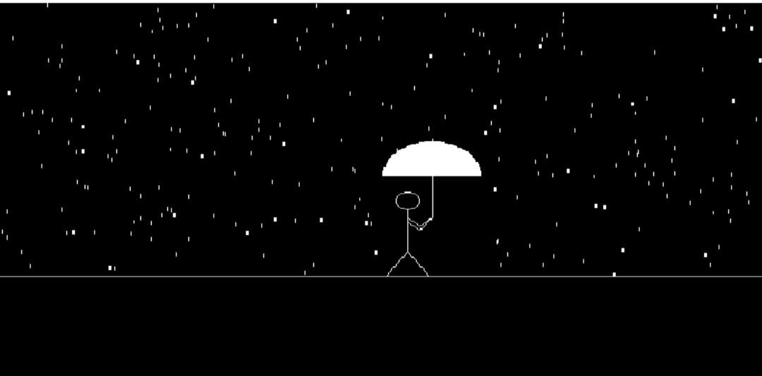**Declaration: -** void setfillstyle (int pattern, int color);

**Figure: Walking man in the rain with an umbrella**

**CONCLUSION:** Using the concept of transformation, an illusion of moving object is achieved.